**SQL ASSIGNMENT-3**

**Database: -**

CREATE TABLE Department(

dept_id INT IDENTITY(1,1)PRIMARY KEY,

dept_name NVARCHAR(50) NOT NULL,

);

INSERT INTO Department

VALUES

('Finance'),

('Managment'),

('HR'),

('Devlopement'),

('Design');

SELECT * FROM Department

CREATE TABLE Employee(

emp_id INT IDENTITY(1,1) PRIMARY KEY,

dept_id INT foreign key references Department(dept_id),

mngr_id INT,

emp_name NVARCHAR(50),

salary INT);

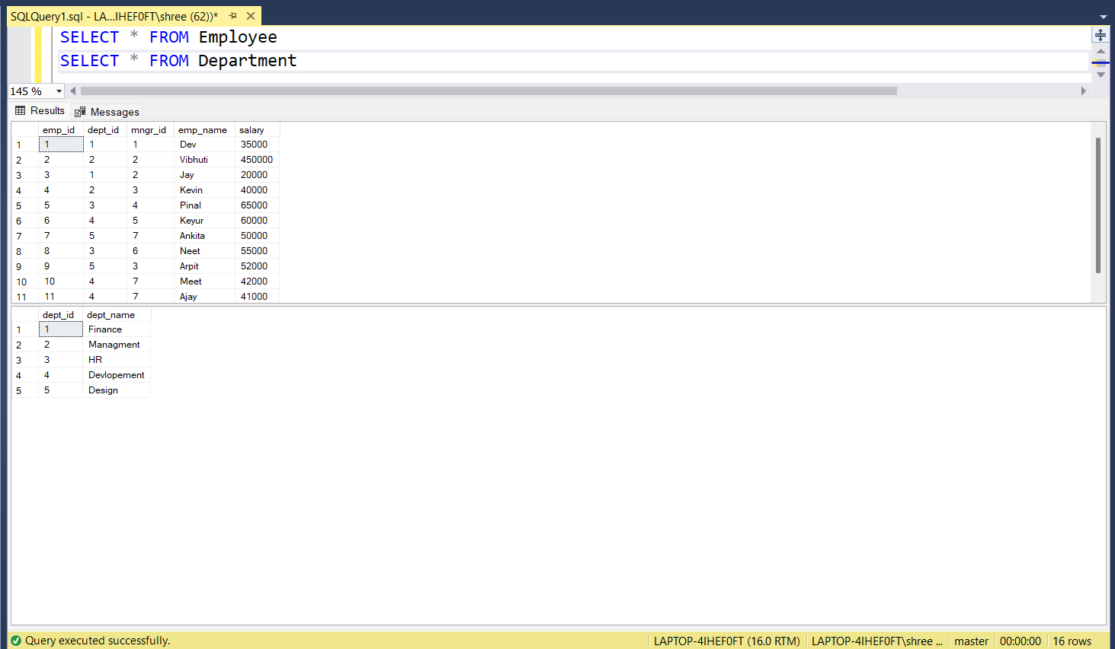

**SQL-Queries**

**1) Write a SQL query to find Employees who have the biggest salary in their Department.**

Answer: -

SELECT

Employee.emp_id,

Employee.emp_name,

Employee.dept_id,

Department.dept_name,

Employee.salary

FROM Employee

INNER JOIN Department ON Employee.dept_id = Department.dept_id

WHERE salary IN (

SELECT MAX(salary) AS [Max. salary] FROM Employee

GROUP BY dept_id

)

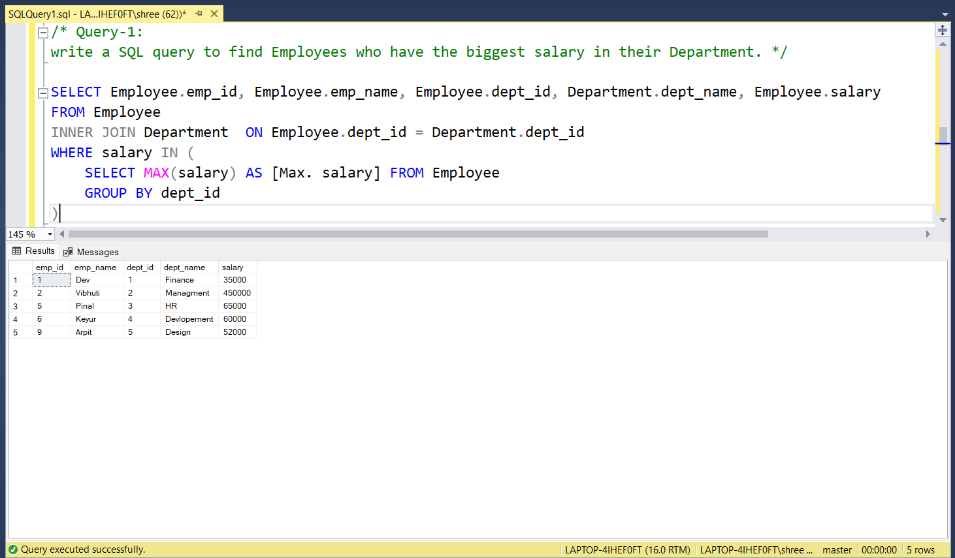

**2)** **Write a SQL query to find Departments that have less than 3 people in it.**

Answer: -

SELECT Department.dept_name

FROM Employee

INNER JOIN Department ON Employee.dept_id = Department.dept_id

GROUP BY Department.dept_name

HAVING COUNT(*) < 3

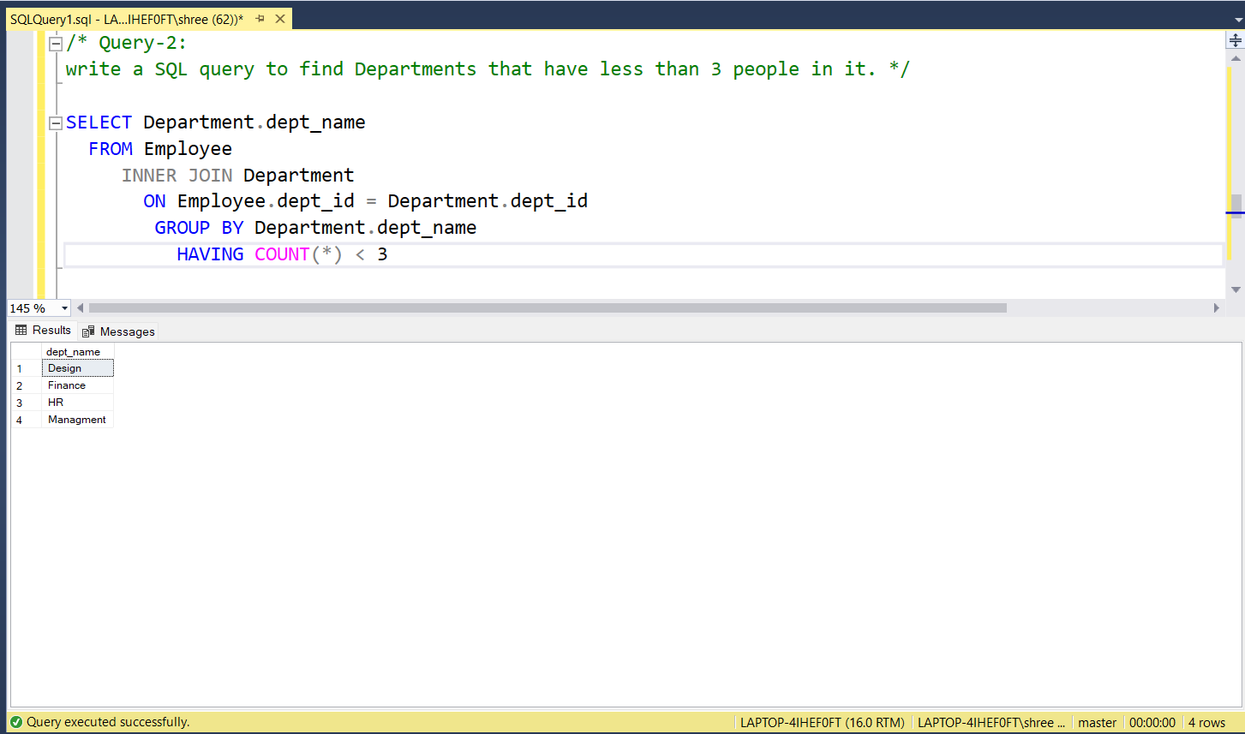

**3) Write a SQL query to find All Department along with the number of people there.**

Answer: -

SELECT

Department.dept_id,Department.dept_name,

COUNT(*) AS [Total People]

FROM Employee INNER JOIN Department

ON Employee.dept_id = Department.dept_id

GROUP BY Department.dept_id,Department.dept_name

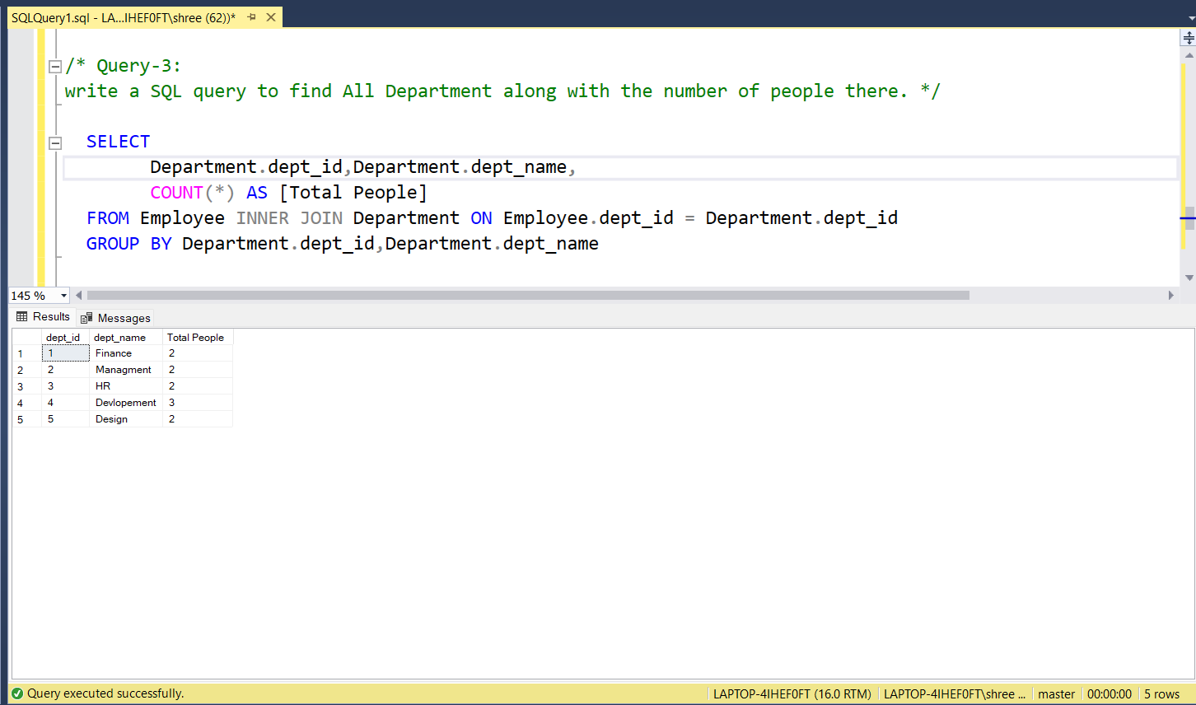

**4) Write a SQL query to find All Department along with the total salary there.**

Answer: -

SELECT

Department.dept_id,Department.dept_name,

SUM(salary) AS [Total Salary]

FROM Employee INNER JOIN Department

ON Employee.dept_id = Department.dept_id

GROUP BY Department.dept_id,Department.dept_name

